# The University of Sydney

## ElEC5510

## Satellite Communication Systems

## Group Project 2016

## Group 7

## Linbo Tian 460166418

**Tan Yan 460172899**

**DanYang Wang 460157900**

**Ruihan Wang 460259064**

# Introduction and background

# DVB-S

The digital video broadcasting-satellite is the physical layer standard for satellite television broadcast and data services. The overlaid transport stream is mandated as MPEG-2, known as MPEG transport stream (MPEG-TS). A DVB-S baseband transmitter consists of four blocks: the outer Reed-Solomon encoder; convolutional interleaver, inner convolutional encoder, and QPSK modulator.

QPSK Modulator

Convolutional encoder

Convolutional interleaver

RS Encoder

Wireless Channel

QPSK Demodulator

Convolutional decoder

Convolutional de-interleaver

RS decoder

## DVB-S2

The DVB-S2 standard is a flexible standard which defines a second generation modulation and channel coding system for satellite communications. A t-error correcting BCH (Nbch, Kbch) code is applied to each input data stream of length Kbch to generate an error protected packet. In DVB-S2 4 the following different modulations are used: QPSK, 8PSK, 16 APSK, and 32 APSK.

BCH Encoder

LDPC Encoder

Block interleaver

QPSK/8PSK Modulator

BCH Decoder

LDPC Decoder

De-interleaver

QPSK/8PSK Demodulator

Wireless Channel

## Overview

In this project, we learned how to plan, implement, analyze and simulate satellite communication systems by utilize DVB-S and DVB-S II standards. First of all, we have finished some calculations about link budget in part I in different cases. In part II, baseband simulations and performance analysis of the DVB-S standard has been achieved with proper Matlab code words. Part III involves works of baseband simulations and performance and analysis of the DVB-S II standard.

## Part I:

Clear sky condition

1. The system noise temperature Ts , including the antenna and the receiver, consisting of LNB, cable and set-top box noises.
$$Ts=Ta+Tr=40+75.9=115.9K=20.64 dB$$

2. The receive antenna gain Gr , and hence the receiver figure of merit, the G/T ratio.

$$Gr=\frac{4πAe}{λ^{2}}=2128.1=33.28 dB$$

And since the $Ts=20.64 dB,$ we can get [$\frac{Gr}{Ts}$] = [Gr]-[$Ts$]=33.28-20.64 dB

1. The C/N0 ratio.

Since R=38500 km

f=3960 MHz

$$\left[losses\right]p=\left[{（\frac{4πR}{λ}）}^{2}\right]=196 dB$$

Since the miscellaneous losses is [losses]m=2 dB

The total losses is

[losses]t=196 + 2=198 dB

$$\left[\frac{G}{T}\right]=\left[\frac{Gr}{Ts}\right]=12.639dB$$

$$\left[\frac{C}{N_{0}}\right]=\left[EIRP\right]+\left[\frac{G}{T}\right]-\left[losses\right]-\left[k\right]=39-198+12.639+228.6=82.23dBHz$$

1. For a DVB-S system, find the Eb/N0 ratio, where Eb refers to the information bits before the RS decoder. Comparing your calculated ratio to the required Eb/N0 in the DVB-S standard Table 3 [1], shown in Table 4 below, find the SNR margin. Is the reception quality acceptable? Which code rate should be selected for transmission and why?

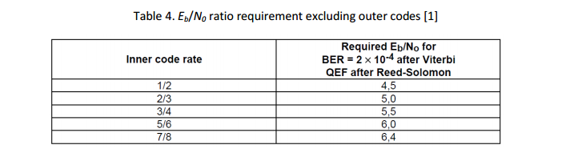

As we know, the $\left[\frac{C}{N_{o}}\right]=\left[r_{b}\right]+[\frac{E_{b}}{N_{o}}]$

$${[r}_{b}]=[b*r_{s}]$$

$b=\log_{2}M$

For QPSK, M=4.

b = 2

$${[r}_{b}]=68.5 dB$$

$$\left[\frac{E_{b}}{N_{o}}\right]=82.238-68.5=13.738 dB$$

The calculated Eb/No ration is

$$\left[\frac{E_{b}}{N_{o}}\right]=13.738-10\log_{10}FECcoderate$$

The SNR margin can be obtained by comparing the table,

For inner code rate 1/2, the SNR margin is 12.25 dB.

For inner code rate 3/4, the SNR margin is 9.483 dB.

For inner code rate 5/6, the SNR margin is 8.5 dB.

It is acceptable and 1/2 code rate should be selected for transmission, since larger SNR margin resulting in better signal.

1. For a DVB-S2 system, find the Eb/N0 ratio, where Eb refers to the information bits before the BCH decoder. Comparing your calculated ratio to the required Eb/N0 in the DVB-S2 standard Table 13 [2], is shown in Table 5 below, find the SNR margin. Is the reception quality acceptable? Which code rate should be selected for transmission and why?

[$\frac{E_{b}}{N_{o}}]_{cal}=\left[\frac{E_{s}}{N_{o}}\right]-10logFEC$

$[\frac{E_{b}}{N_{o}}]_{required}=\left[\frac{E_{s}}{N_{o}}\right]-10log⁡(η)$

SNR= [$\frac{E_{b}}{N_{o}}]_{cal}-[\frac{E_{b}}{N_{o}}]_{required}$

for QPSK 1/4, $\left[\frac{E_{s}}{N_{o}}\right]$ = -2.35 dB $, η=0.49$, $[\frac{E_{b}}{N_{o}}]_{required}=0.75 dB$

for QPSK 1/2, $\left[\frac{E_{s}}{N_{o}}\right]$ = 1 dB $, η=0.99$, $[\frac{E_{b}}{N_{o}}]_{required}=1.05 dB$

for QPSK 1/4, $\left[\frac{E_{s}}{N_{o}}\right]$ = 5.18 dB $, η=1.655$, $[\frac{E_{b}}{N_{o}}]_{required}=2.991 dB$

for QPSK 1/4, $\left[\frac{E_{s}}{N_{o}}\right]$ = 6.2 dB $, η=1.766$, $[\frac{E_{b}}{N_{o}}]_{required}=3.73 dB$

For different QPSK mode, we get the result shown below,

For QPSK 1/4 : $\left[\frac{E_{b}}{N_{o}}\right]=19.759 dB$, the SNR margin = 19.009 dB.

For QPSK 1/2: $\left[\frac{E_{b}}{N_{o}}\right]=16.749 dB$, the SNR margin = 15.698 dB.

For QPSK 5/6: $\left[\frac{E_{b}}{N_{o}}\right]=14.53 dB$, the SNR margin = 11.54 dB.

For QPSK 8/9: $\left[\frac{E_{b}}{N_{o}}\right]=14.25 dB$, the SNR margin = 10.5 dB.

It is acceptable and the Mode QPSK 1/4 has largest SNR margin, which should be selected for transmission.

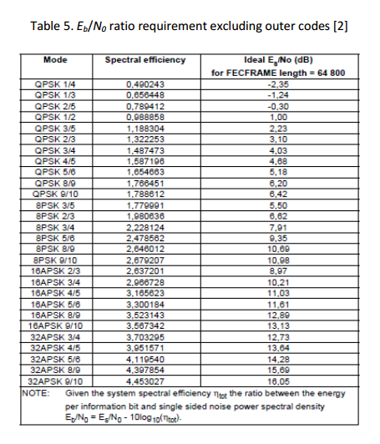

6) Calculate Es/N0 ratio, where Es refers to the energy per QPSK symbol before the RS decoder.

$$\left[\frac{Es}{N_{0}}\right]=\left[\frac{E_{b}}{N_{0}}\right]+\left[10\log{η}\right]$$

So, for Mode QPSK 1/4: $\left[\frac{E_{s}}{N_{o}}\right]=19.759+10log0.49=16.66 dB$

QPSK 1/2: $\left[\frac{E_{s}}{N_{o}}\right]=16.748+10log0.988=16.69 dB$

QPSK 5/6: $\left[\frac{E_{s}}{N_{o}}\right]=14.53+10log1.65=16.70 dB$

QPSK 8/9: $\left[\frac{E_{s}}{N_{o}}\right]=14.25+10log1.766=16.719 dB$

Rain condition

1. Calculate the rain attenuation.

It is known that R=36.8 mm/h, a=0.0007, b=1.13

$γ=ak^{b}=0.0007*{36.8}^{1.13}=0.04116 dB$

for the L, we can get from the latitude, which is 33.9 degrees,

$$L(km)=\left\{\begin{aligned}4-0.075\left(∅-36\right), ∅>36° \\ 4, 0≤∅≤36°\end{aligned}\right.$$

So, L=4

$$\left[A\right]=[γ*L*r]=0.054dB$$

1. Assuming the rain attenuation is entirely absorptive, calculate the equivalent noise temperature caused by the rain attenuation Train.

$Train=Ta\left(1-\frac{1}{A}\right)$,

$$Ta=280 k$$

So, $Train=3.45 k$

1. Calculate the SNR margin for both the DVB-S and DVB-S2 under the raining condition and comment on which code rate performs best.

$$T_{total}=T_{antenna}+T_{reveiver}+T_{rain}$$

$T_{total}$ =40+73.9+3.45=119.35K

[$T_{total}$]=20.768dB

$${\left[\frac{G}{T}\right]}^{'}=33.28-20.77=12.51dB$$

$$\left[\frac{C}{N_{0}}\right]=\left[EIRP\right]+{\left[\frac{G}{T}\right]}^{'}-\left[loss\right]-\left[k\right]-\left[A\right]$$

$$=12.51+82.23-12.639=82.056dB$$

For QPSK modulator:

$\left[\frac{E_{b}}{N_{0}}\right]=\left[\frac{C}{N_{0}}\right]-\left[r_{b}\right]=$ 82.056-68.5=13.556dB

Required $\left[\frac{E_{b}}{N_{0}}\right]=\left[\frac{E_{b}}{N_{0}}\right]-10logFEC$

SNR= calculated $\left[\frac{E_{b}}{N_{o}}\right]-required\left[\frac{E_{b}}{N_{o}}\right]$

For DVB-S system:

inner code rate 1/2, the $\left[\frac{E_{b}}{N_{0}}\right]=16.576 dB$, SNR margin = 12.076 dB.

inner code rate 3/4, the $\left[\frac{E_{b}}{N_{0}}\right]=14.815 dB,$ SNR margin = 9.315 dB.

inner code rate 5/6, the $\left[\frac{E_{b}}{N_{0}}\right]=14.358 dB,$ SNR margin = 8.358 dB.

We choose the 1/2 code rate for DVB-S.

For DVB-S2 system:

inner code rate 1/4, the $\left[\frac{E_{b}}{N_{0}}\right]=19.586 dB$, SNR margin = 18.836 dB.

inner code rate 1/2, the $\left[\frac{E_{b}}{N_{0}}\right]=14.815 dB,$ SNR margin = 15.526 dB.

inner code rate 5/6, the $\left[\frac{E_{b}}{N_{0}}\right]=14.358 dB,$ SNR margin = 11.368 dB.

inner code rate 8/9, the $\left[\frac{E_{b}}{N_{0}}\right]=14.077 dB,$ SNR margin = 10.347 dB.

We choose 1/4 code rate for DVB-S2.

4) Assume that the transponder is operating in the Ku band with the following parameters: Carrier frequency fc=12706.5 MHz EIRP=50 dBW Dish diameter D = 0.9 m Symbol rate rs=22.5 M symbols/sec CCIR rain attenuation parameters: a=0.05, b=1.28, r=0.33 All other parameters not mentioned here are not changed relative to the C-band transmission specified in Part I. Calculate the SNR margins under clear sky and raining condition for the code rates considered for both DVB-S and DVB-S2, respectively. Is the reception quality acceptable in each condition? Which code rates for DVB standards should be selected for transmissions and why?

1. under the clear sky

$$\left[Ts\right]=15.9k=20.64 dB$$

$$\left[Gr\right]=10\log\left\{0.55×{\left(\frac{π×0.9×12706.5×{10}^{6}}{3×{10}^{8}}\right)}^{2}\right\}=38.97 dB$$

$$\left[\frac{G}{T}\right]=38.97-20.64=18.33dB$$

$$\left[\frac{C}{N_{0}}\right]=\left[EIRP\right]+\left[\frac{G}{T}\right]-{\left[Loss\right]}_{total}-[k]$$

For Ku band, $\left[EIRP\right]=50 dBW$

${[L}_{p}]=10log(\frac{4πRf}{c})^{2}$ =206.23 dB

$${\left[Loss\right]}_{total}=\left[loss\right]p+\left[loss\right]m=206.23+2=208.23 dB$$

$$\left[\frac{C}{N_{0}}\right]=88.7 dB$$

$$\left[r_{b}\right]=10\log\left(22.5×{10}^{6}\right)+\left[2\right]=76.5 dB$$

$$\left[\frac{E_{b}}{N_{0}}\right]=\left[\frac{C}{N_{0}}\right]-\left[r_{b}\right]=12.2dB$$

$$required\left[\frac{E_{b}}{N_{0}}\right]=12.2-10logFEC$$

SNR= calculated $\left[\frac{E_{b}}{N_{o}}\right]-required\left[\frac{E_{b}}{N_{o}}\right]$

For DVB-S system:

inner code rate 1/2, the $\left[\frac{E_{b}}{N_{0}}\right]=15.2 dB$, SNR margin = 10.7 dB.

inner code rate 3/4, the $\left[\frac{E_{b}}{N_{0}}\right]=13.45 dB,$ SNR margin = 7.9 dB.

inner code rate 5/6, the $\left[\frac{E_{b}}{N_{0}}\right]=12.99 dB,$ SNR margin = 6.99 dB.

We choose 1/2 code rate for DVB-S.

For DVB-S2 system:

inner code rate 1/4, the SNR margin = 17.472dB.

inner code rate 1/2, the SNR margin = 14.161 dB.

inner code rate 5/6, the SNR margin = 10.003 dB.

inner code rate 8/9, the SNR margin = 9.983 dB.

2. under raining condition

$$γ=0.03×{36.8}^{1.28}$$

$A=γ∙L∙r$ =6.67 dB

$T_{rain}=280×\left(1-\frac{1}{A}\right)$ = 219.67K

${T_{S}}^{'}$ =40+73.9+219.67=335.67K=25.258 dB

$$\left[\frac{G^{'}}{T}\right]=38.97-25.258=13.712 dB$$

$$\left[\frac{C}{N_{0}}\right]=50+13.712-208.23+228.6-6.67=77.42$$

For DVB-S system:

inner code rate 1/2, the SNR margin = -0.58 dB.

inner code rate 3/4, the SNR margin = -3.33 dB.

inner code rate 5/6, the SNR margin = -4.3 dB.

We can not choose any one, since the SNR margin all less than o, so the reception quality is not acceptable.

For DVB-S2 system:

inner code rate 1/4, the SNR margin = 6.182 dB.

inner code rate 1/2, the SNR margin = 2.872 dB.

inner code rate 5/6, the SNR margin = -1.286dB.

inner code rate 8/9, the SNR margin = -2.31 dB.

We can only choose 1/4 and 1/2 code rate as the SNR margin should be more than o.

**Part II:**

In part II, the objective is to achieve the simulation of channel coding in DVB-S. The inner code in the DVB-S standard is a convolutional code with a memory order m=6, three levels of puncturing is 1/2, 2/3 and 5/6 respectively. Puncturing pattern for code rate 1/2 is I=X1 Q= Y1, I=X1Y2Y3 Q=Y1X3X4 for the code rate 2/3, I=X1Y2Y4 Q=Y1X3X5 for the code rate 5/6. For baseband simulation without Reed-Solomon code, the we only need to define the parameters for convolutional coder, modulation function and AWGN channel, and we also define an uncoded stream to compare the BER performance.

Convolutional encoder

QPSK Modulator

Convolutional decoder

QPSK Demodulator

Wireless Channel

Figure 2.1 Block diagram of DVB-S baseband without outer RS code

In order to determine how the outer coding affects the BER performance of the AWGN channel, we also introduce Reed-Solomon codes and convolutional interleaver. For the other hand, we compare the differences of BER performance through Rayleigh channel and AWGN channel.

Wireless Channel

QPSK Demodulator

Convolutional decoder

Convolutional de-interleaver

RS decoder

QPSK Modulator

Convolutional encoder

Convolutional interleaver

RS Encoder

Figure 2.2 block diagram of DVB-S with outer codes

The figure below indicates that with the puncturing rate increasing, the BER performance shows the opposite trend, since the when the puncturing is used to discarded some bits in order to increase the code rate, resulting in when the rate is higher there will be more bits discarded, and the BER performance will be decreased.

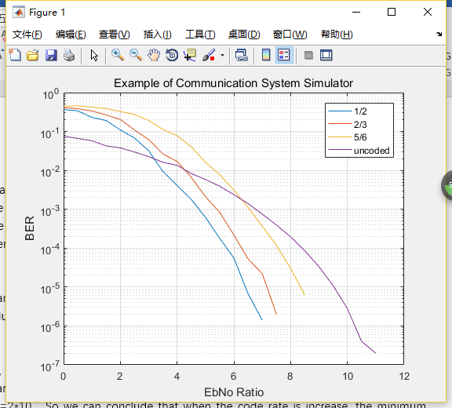

Figure 2.3 BER vs Eb/No curves for three levels and uncoded

when the standard RS outer code is used before the convolutional code, the BER will performance will be increased significantly, as the Eb/No is less to achieve the same BER.

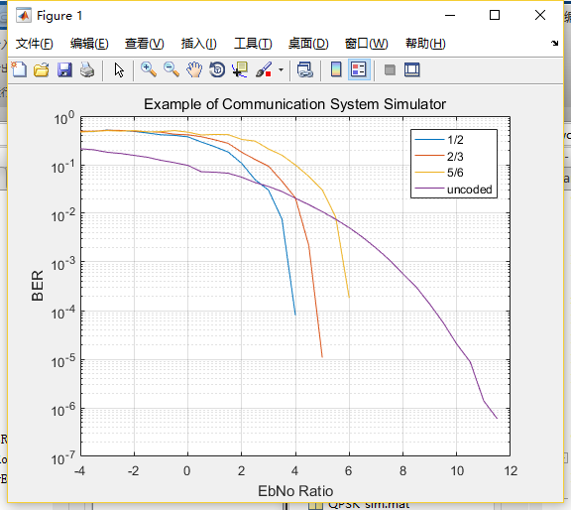

Figure 2.4 BER vs Eb/No with RS outer code

For 1/2 code rate, the minimum Eb/No is around 3.9 dB that meet BER=2*10-4. For 2/3 code rate, the minimum Eb/No is around 4.7 dB that meet BER=2*10-4. For 5/6 code rate, the minimum Eb/No is around 5.99 dB that meet BER=2*10-4. So we can conclude that when the code rate is increase, the minimum Eb/No requirement is also increased. This is mainly because as the code rate increase, there is more redundancy, in this case, the capability of correcting error is higher. Therefore, it requires less minimum Eb/No to achieve the same BER.

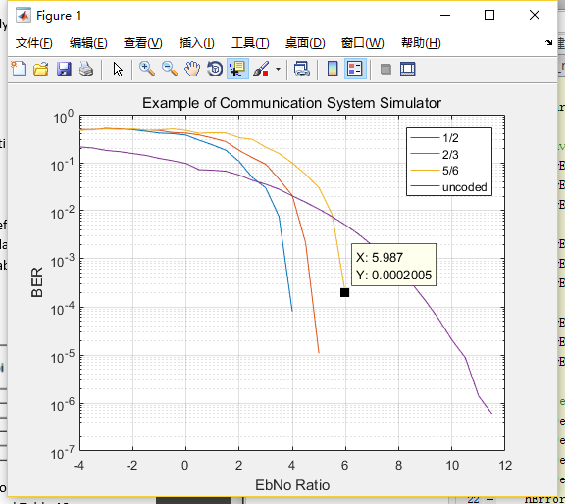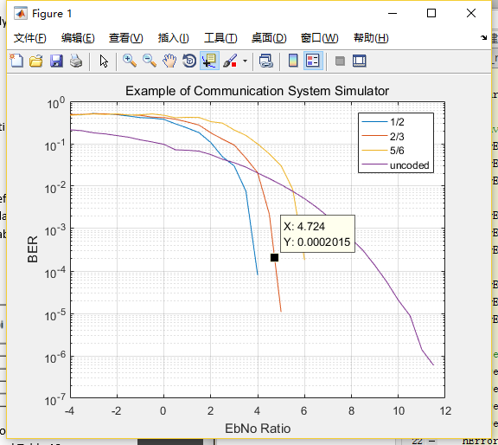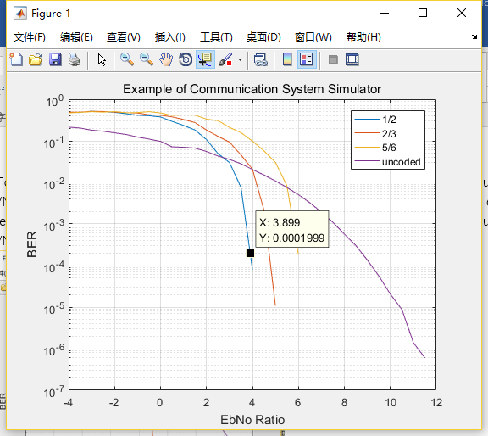

Figure 2.5 Three levels of code rate achieve the same BER

The required minimum Eb/No for the three levels code rates 1/2, 2/3, 5/6 are 4.5, 5.0 and 6.0, which are higher and almost consistent as the results from our simulation. This is mainly because there are some discrepancy happened when simulate.

In the case of only inner code, the coding gain with the code rate of 1/2 is around 2.53 dB, in contrast, the coding gain is around 1.95 dB with the code rate of 2/3. The coding gain with the code rate of 5/6 is around 0.71 dB. the formula of the asymptotic coding gain of a block code with hard decision decoding is

G=10log10()

Where the dfree of code rate 1/2 is 10, therefore the coding gain is calculated as 3.98 dB, in the case of the dfree of code rate 2/3 is 6, the coding gain is calculated as 3.01 dB. The dfree of code rate 5/6 is 4, the coding gain is calculated as 2.218 dB.

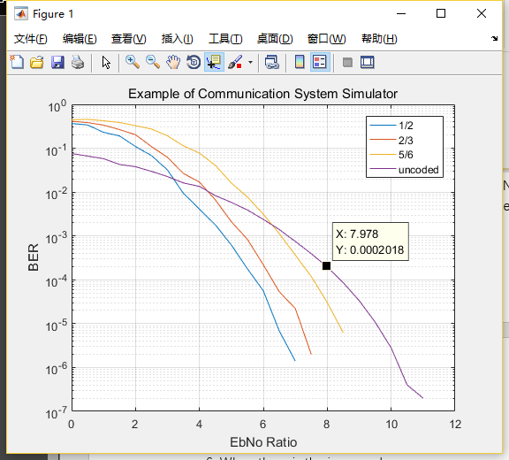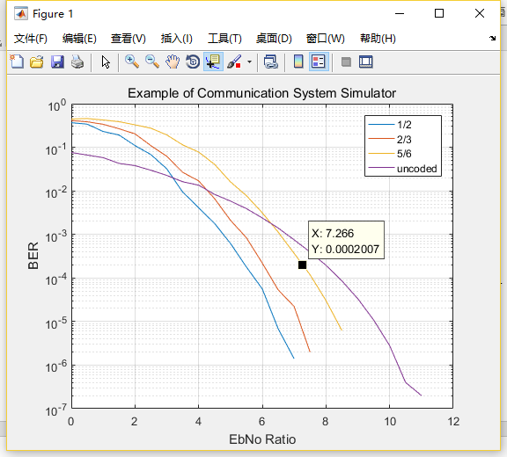

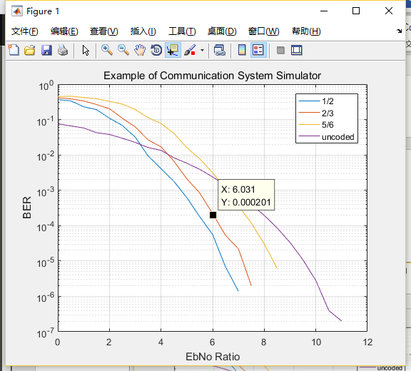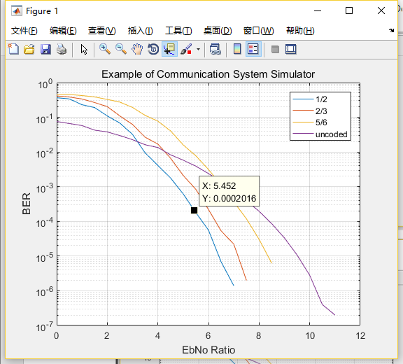

Figure 2.6 the minimum Eb/No for different inner codes

The simulation in the Rayleigh fading channel is shown below, by comparing it with the AWGN channel results, we can get the conclusion that, the BER performance will be decrease in the Rayleigh fading channel.

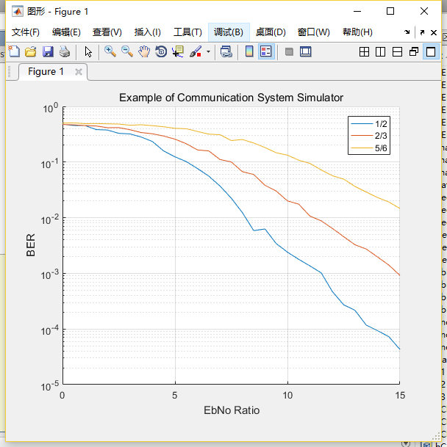

Figure 2.7 comparison Rayleigh fading channel with AWGN channel results

## Part III:

In this part, the inner code in the DVB-S2 standard is an LDPC code, we determine the BER performance of the LDPC two different code rates (2/5,9/10) for QPSK modulation and two different code rates (2/3,8/9) for 8PSK modulation.

Wireless Channel

QPSK/8PSK Demodulator

De-interleaver

LDPC Decoder

QPSK/8PSK Modulator

Block interleaver

LDPC Encoder

Figure 3.1 Block diagram of DVB-S2 using LDPC codes as inner codes

We also introduce BCH outer code before the LDPC code to determine how the interleaver affects the overall BER performance. For the other hand, we compare the differences of BER performance through Rayleigh channel and AWGN channel.

BCH Encoder

LDPC Encoder

Block interleaver

QPSK/8PSK Modulator

BCH Decoder

LDPC Decoder

De-interleaver

QPSK/8PSK Demodulator

Wireless Channel

Figure 3.2 Block diagram of DVB-S2 using BCH codes as outer codes

The figure below indicates that with code rate increasing, the BER performance shows the opposite trend, since the lower code rates add more redundancy, and this will increase the capability of error correcting, thus the BER performance will be decreased. And the overall BER performance of QPSK is better than 8PSK, since the 8PSK has a smaller minimum Euclidian distance, and this will result in the higher probability of error, so the QPSK will have an overall BER performance.

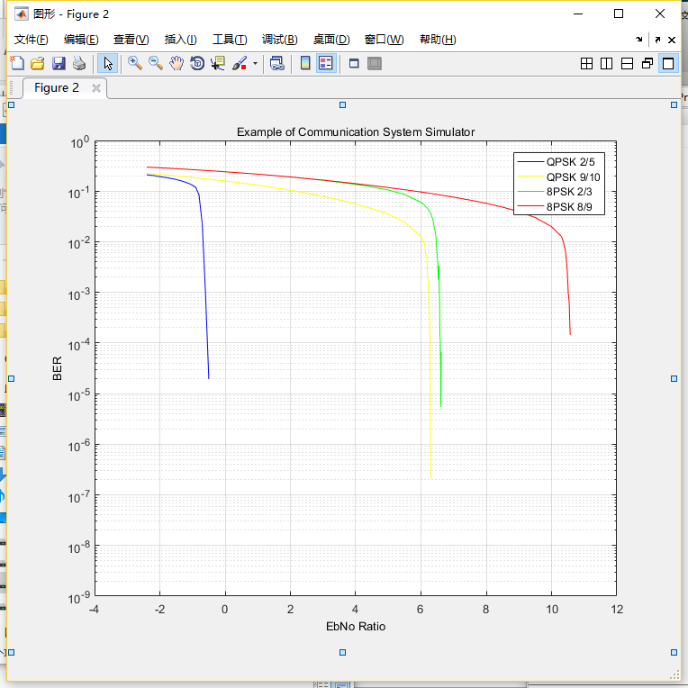

Figure 3.3 BER curves of LDPC in different code rate and modulation

Unfortunately, we did not finish the case when the standard BCH outer code is used before the LDPC code, but as we know the BCH is used to improve the BER performance, hence the outer coding will improve the overall BER performance.

When the block interleaver is used for 8psk modulated signals. We guess there will be a great improvement of BER.

We can also get the conclusion that, the BER performance will be decrease in the Rayleigh fading channel from the case in DVB-S.

## CONCLUSION IV:

In the link budget calculation, our group get familiar with the formulas and in different cases how to do the calculation. In the DVB-S, the RS code affects the encoding and the outer coding affects the BER performance of the AWGN channel. The BER performance will increase when using the RS outer code before convolution. For the same BER, the larger coding rate,the less SNR it needs.Afterwards,in the Rayleigh fading channel, the BER performance will be decrease compared to the AWGN channel. In the DVB-S2,the BER performance shows the opposite trend, the lower code rate ,the worse BER performance.

It is important to note that although DVB-S2 has performance gains over DVB-S, DVBS is still used around the world, because it is simpler and more cost effective to maintain.

**REFERENCES:**

[1] European Telecommunications Standards Institute, ”Digital Video Broadcasting (DVB),” in European standard (Telecommunications series) vol. EN 300 421, ed, 1997.

[2] M. Cominetti and A. Morello, ”Digital Video Broadcasting Over Satellite (DVB-S): A System for Broadcasting and Contribution Applications,” International Journal of Satellite Communications, vol. 18, pp. 393-410, 2000.

[3]ETSI EN 300421,Digital Video Broadcasting (DVB);Framing structure, channel coding and modulation11/12 GHz satellite services,V1.1.2 (1997-08).

[4] ETSI EN 302307-1, Digital Video Broadcasting (DVB); Second generation framing structure, channel coding and modulation systems for Broadcasting, Interactive Services, News Gathering and other broadband satellite applications; Part I: DVB-S2), March 2013.

[5] ETSI TR 102 376 (V1.1.1), Digital Video Broadcasting (DVB); User guidelines for the second generation system for Broadcasting, Interactive Services, News Gathering and other broadband satellite applications (DVB-S2), Februry 2005.

[6] . Khattiya and S. Choomchuay, "An application of rate-adaptive RS-codes in wireless Body Area Network", 2015 12th International Conference on Electrical Engineering/Electronics, Computer, Telecommunications and Information Technology (ECTI-CON), 2015.

[7]2016. [Online]. Available: http://www.math.umn.edu/~garrett/coding/Overheads/19_hamming_bch.pdf.

[8]Digital Video Broadcasting (DVB): Framing structure, channel coding and modulation for 11/12 GHz satellite services. Available Online: http://www.etsi.org/deliver/etsi_en/300400_300499/300421/01.01.02_60/en_300421v0 10102p.pdf